
Fire Evacuation Procedure

Banbury Bumbles Outdoor Learning and Therapeutic Centre
Effective Date: September 2026
Review Date: Yearly

Owner and Manager: Phili Robins

Purpose
To ensure all children, staff, and visitors are safely evacuated in the event of a fire or wildfire.

If Fire is Discovered
- Raise the alarm immediately by blowing a whistle 3 times (staff know 3 times means fire)
- Practice will ensure all staff and children know this means freeze
- Gather all children and staff in and do an initial head count
- Evacuate calmly, quickly but walking to the top of the paddock behind compost heap (see map below)
- Do a register to account for all children and staff
- When safe to do so, call 999 and request and the Fire Service: Using What 3 Words for location: /// Bravery.scoping.among (main entrance gate)
- Contact all children’s parents to evacuate children off site as soon as possible if necessary
- If the fire can be put out with fire blanket, water or fire extinguisher do, but this must not mean leaving the children unattended or with low staffing ratios.

Lockdown Procedure

Banbury Bumbles Outdoor Learning and Therapeutic Centre
Effective Date: September 2026
Review Date: Yearly

Owner and Manager: Phili Robins

Purpose
To protect children from external threats such as:
- dangerous individuals
- aggressive animals
- severe weather where movement is unsafe
- nearby police incidents

Lockdown Signal
- Signal a lockdown with 1 long whistle
- Initiating a freeze response in children
- Gather children and staff in doing an initial head count
- Keep everyone calm and quiet and take the safest route to the stable block (see on map below)
- The stable block has a lockable latch with the padlock on the inside, and an emergency torch only to be used for the lockdown procedure
- Do a register and contact the police on 999: Using What 3 Words for location: /// bravery.scoping.among (main entrance gate)
- Stay on the phone to the emergency services and follow their instructions
- Keep children as calm and quiet as possible

If we are conducting activities in the woods, and it is safer to stay in a sheltered hidden spot than come out to the open meadow, we will stay put, stay low and stay together.

Continue the procedure as above with register, calm and quiet approach and emergency service phone call. In this case tell the emergency services we are hidden in What 3 Words location /// shoving.handle.uppermost (central woods see map below)

Lockdown must only end when the emergency services say it is safe.

When lockdown has ended parents/carers will be contacted.

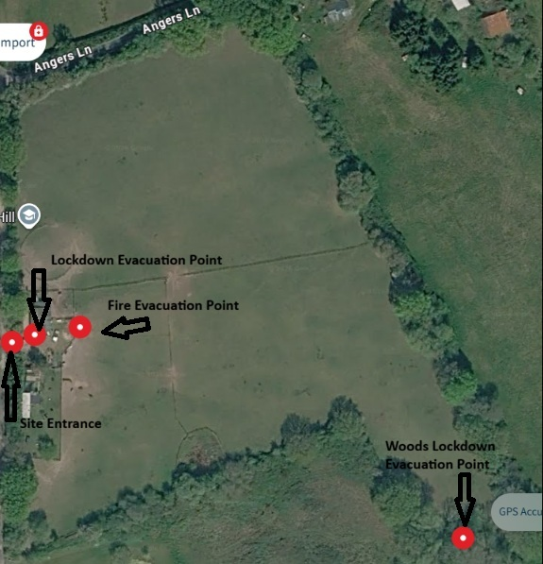

Review
These procedures will be reviewed annually or sooner if:
- Legislation changes.
- Guidance changes.
- An incident or practice highlights the need for revision
- These procedures will be practiced and recorded once each term to ensure familiarity and to find faults and improvements
Signed:
Name: Phili Robins
Role: Owner/Manager
Date:

Procedure and Date | Time taken to complete procedure | Comments on success or areas for improvements | Signed
Fire Procedure
Lockdown Procedure
Fire Procedure
Lockdown Procedure
Fire Procedure
Lockdown Procedure

